Topic 3 Virtual Private Network (VPN)

Topic lessons:
1. Introduction
2. Virtual Private Networks (VPN)
3. VPN Implementation
4. Fundamental IP security (IPSec)
5. IPSec Security Protocols
6. Wrap-Up

Lesson 1 Introduction

Topical Goals

In today’s economy, companies have dramatically expanded the scope of their businesses. They may need to set up offices and facilities across the country or even around the world. How to maintain fast, secure and reliable communications among different business locations and remote users becomes very important for those businesses.

Until fairly recently, many of them use leased lines to connect their private networks at different geographic area. The advantages of leased line are its reliability, performance and security. But using leased lines can be expensive and often the cost rises exponentially as the distance between the offices increases.

As the popularity of the Internet grew, many companies are turning to the Internet to extend their own networks and accommodate the needs of remote employees and distant offices. Virtual Private Network (VPN) brings these companies such a solution to use the open, distributed infrastructure of the Internet to provide remote offices or individual users with secure access to a company’s private network.

This topic will provide a fundamental description of VPN along with an important security standard IPSec which ensures the communications over VPN are private and secure.

After reading this topic, you should be able to:

- Give an overview of VPN including its benefit, different types and its security mechanisms.
- Describe the implementation of two different types of VPN
- Introduce IPSec and the security services provided by IPSec
- Discuss two important protocols supported by IPSec: AH and ESP

Lesson 2 Virtual Private Network (VPN)

Lesson Objectives
When a company tries to connect its private networks together using a public resource, meaning the wires and routers that make up the Internet, it has no control over the other people who are using the public resource. This leaves the company susceptible to security issues when the data is transmitted between private networks over the Internet. The older solution is to build a dedicated and direct connection, such as a leased line, between private networks that can only be used by the authorized users of the company. Many companies have chosen this route because of the need for security and reliability in connecting their remote offices. It is reliable, fast, but it is very expensive to build and maintain this connection even the sites are very close to each other.
Virtual private network (VPN) provides a solution for an organization to use a public network infrastructure, such as the Internet, to offer secure and reliable data communication between its private networks at different geographic locations.

This lesson provides an overview of the basic principles which are important to understand VPN technology, including the benefit, different types of VPN and the security mechanisms used by VPN.

After reading this lesson, you should be able to:

- Define a VPN and explain how a VPN works
- Highlight VPN benefits
- Define remote-access VPN and site-to-site VPN
- Overview four security mechanisms of a VPN

What is a VPN?

VPN stands for Virtual Private Network. It is a network infrastructure constructed over a public infrastructure (i.e. the Internet) to deliver private network services. A VPN permits companies, through the use of security mechanisms such as encryption and tunneling, to establish secure and encrypted connections between private networks over the Internet.

Figure 3-1 shows a typical VPN. It has a single central network at the corporate office of a company, a single LAN (local area network) at its remote office, a single LAN at its partner’s office, and individual users connecting from out in the field or working from home.

The VPN enables other LANs and individual users to communicate with the central network in a secure and reliable manner. Instead of using a dedicated, real wire connection such as a leased line, a VPN uses the Internet as the medium to build “virtual” connections that link the company’s central network to the remote sites or mobile employee. The traffic is encrypted for confidentiality and then "wrapped" with enough networking information for the intervening machines on the virtual connections to pass it to the destination. The intervening machines can not read contents of the data packet. Thus the traffic can be routed back and forth with privacy and security.

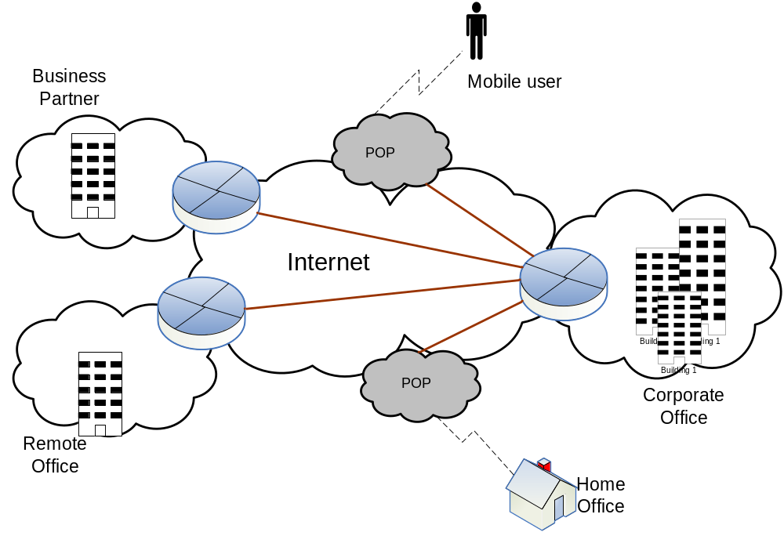
Figure 3-1 A typical VPN
VPN is transparent to end users. End users do not need any knowledge about VPN components and how to establish a VPN connection to access the corporate LAN. For example, when a mobile user wants to check e-mail, the user simply uses his or her e-mail client to request a download as if directly connected to the corporate LAN.
From a user’s perspective, the nature of the intermediate network over the Internet that a VPN utilizes to build “virtual” connections is irrelevant because it appears as if the data is being sent over a dedicated private connection. In this way, the secure connection across the intermediate network appears to the user as a private network communication despite the fact that this communication is occurring over the Internet. This is why we call it a “virtual” connection and is essentially how a VPN works.
VPN Benefit
VPN is a popular cost-effective way to securely connect offices, remote workers and mobile workers back into the corporate network. It provides many benefits for a company including:
Security – VPN provides a high level of security using advanced security methods (e.g. encryption and authentication) that protect data from unauthorized access. It uses the Internet as the medium for transporting data, while maintaining the privacy of communications to ensure only authorized users can access the network and the data cannot be intercepted. It completely hides you from others on the public network infrastructure.
Scalability – VPN that utilizes the Internet enables companies to add large amount of capacity without adding significant infrastructure. A VPN can grow to accommodate more users and different locations as long as the Internet access is available. Adding additional components to a VPN infrastructure is much easier than a lease line system previously used by many companies.
Flexibility – VPN allows a company to keep its employees and partners securely connected to central network resources no matter where they are. It provides access to the entire network with any-to-any connectivity. VPN can be developed with different applications such as Full-Mesh topology for voice and Hub-and-Spoke for Internet access. The geographic locations of each office matter little in the creation of a VPN.
Cost effectiveness – VPN helps to reduce connectivity charges and operational costs due to the sharing of Internet infrastructure. It enables network connections between sites by utilizing Internet to connect remote offices and remote users to the main corporate site. The cost of traditional lease lines, by contrast, can increases dramatically as an organization grows with more remote users and offices added to its corporate network.
VPN Types

There are two common types of VPN networks: remote access and site-to-site.

Remote Access VPN

A remote access VPN allows remote employee and telecommuters to securely connect to the company’s corporate network inexpensively using the Internet or an Internet Service Provider’s (ISP’s) backbone. It is also called a virtual private dial-up network (VPDN). In the past, the company supported remote users through a toll-free call to reach the company’s private network directly. With the advent of VPN, the remote users can make a local call to their ISP and use the VPN client software on their computers to access the company’s private network. They can basically access the company via the Internet from wherever they are.

Remote-access VPNs permit secure, encrypted connections between a company's private network and remote users and save the expenditures of using toll-free numbers. For instance, a company with hundreds of sales people in the field would greatly benefit from a remote-access VPN.

Site-to-Site VPN

Site-to-site VPN can be used to connect a company’s multiple fixed sites, such as remote offices and central offices, over the Internet. It has replaced a lease line or frame relay connection often used previously by companies to connect sites. There are two types of site-to-site VPN:
Intranet VPN – An intranet VPN is built to connect all of a company’s remotes sites to be a single private network where companies can share information with employees and others with authorization.
Extranet VPN – An extranet VPN is built to connect a company with other companies that it has a working relationship, such as a partner, supplier or customer. This allows all of the various companies to work in a shared environment with controlled network access.
VPN Security Mechanisms

A VPN generally uses the following security mechanisms to keep the connection and data secure: firewalls, encryption, IPSec, and AAA server.

Firewall-based VPN
A firewall provides a strong barrier between your private network and the Internet. A firewall-based VPN can manage the VPN network, terminate the VPN sessions, and also take advantage of the firewall’s built-in security mechanisms, such as restricting access to the internal network. It may also perform network address translation from a public IP address to the corporate office private IP address, and serve up real-time alarms and extensive logging. The existing firewall systems can be enhanced to support VPN services.
Encryption
Encryption ensures privacy and confidentiality of information during its transit over the VPN. It is the process of taking all the data that one computer is sending to another and encoding it into a form that only the other computer will be able to decode.
Encryption is the security mechanism that provides the ‘P’ (privacy) in VPN. In a VPN network, the data is encrypted by using different encryption protocols at the sending end and decrypted at the receiving end. An additional level of security involves encrypting not only the data, but also the originating and receiving network addresses. Popular encryption methods include Data Encryption Standard (DES), Triple DES (3DES), and Blowfish.
IPSec
Internet Protocol Security (IPSec) is a security protocol used by most VPNs to set up private connections that span the Internet between the separate company sites. It is designed to address data confidentiality, integrity, authentication and key management in addition to tunneling. Tunneling can be thought of as the act of encapsulating original (non-secure) IP packets inside of encrypted (secure) IP packets. This works as if sending the data through a "tunnel" that cannot be "entered" by data that is not properly encrypted. Also, tunneling supports the routing of non-routable private IP addresses over public networks such as the Internet, which brings us to the ‘V’ (virtual) in VPN, so that you can send the information to a private address that do not have a public address.

IPSec will be discussed in more detail later in this topic.
AAA Server
For a more secure access in a remote-access VPN, the request to establish a session from a dial-up client can be sent to an AAA (authentication, authorization and accounting) server to check the following:
- Who you are (authentication)
- What you can do (authorization)
- What you actually do (accounting)
The accounting information is used for tracking client usage of the network resources, security auditing, billing and reporting.
Lesson Wrap-Up
VPN solution supports remote access and private data communications over public network as a cheaper alternative to owned or leased lines that can only be used by one company. By addressing security and performance issues, a VPN delivers tangible business benefits with secure communicates and significant cost saving versus other remote-access solutions. Understanding the various VPN solutions can help companies build infrastructures that will support their tactical business needs today as well as their strategic business needs for tomorrow.
Now that you have completed this lesson, you should be able to:
- Define a VPN and explain how a VPN works
- Highlight VPN benefits
- Define remote-access VPN and site-to-site VPN
- Overview four security mechanisms of VPN

Lesson 3 VPN Implementation

Lesson Objective
A VPN is a combination of software and hardware that allow mobile employees, telecommuters, business partners, and remote sites to use a public or “unsecured” medium such as the Internet to establish a secure, private connection with a central network. With a VPN deployed across the Internet, virtual private connections can be established from almost anywhere in the world.
A wide variety of VPN technologies are deployed today. This lesson will discuss components needed in a VPN implementation and two different types of VPN. It will also talk about Cisco’s VPN solution in building these two types of VPN.
After reading this lesson, you should be able to:
- Discuss the basic components of a VPN
- Describe how remote-access VPN and site-to-site VPN work
- Introduce Cisco’s VPN solutions
VPN Components
There are variations of VPN implementations depending on whether the VPN is managed by the customer or the service provider. In all cases, the VPN comprises two endpoints (peers) that may be represented by routers, firewalls, client workstations, or servers.
Specifically, the following options are available for remote users or remote sites to implement a VPN:
- Software VPN client access option used by remote users to build VPN connections (i.e. Cisco VPN software client)
- Remote-site firewall option used by remote sites to support firewalling function and VPN connectivity to corporate networks
- Hardware VPN client option used by remote sites for VPN connectivity to corporate networks
The following options are available in corporate main network to implement a VPN:
- Dedicated VPN server for remote-access VPN (e.g. Cisco VPN concentrator)
- VPN router to route traffic and terminate VPN sessions
- Firewall with VPN functionality (e.g. Cisco PIX firewall)
The company configures the equipment at each end so that data can be transmitted over VPN connections between two VPN peers with privacy. Note that a VPN does not provide complete end-to-end security between user applications and server applications. Antivirus software, system patches, additional layers of encryption to finish the link between user applications and server applications are still required for system security. In addition, firewalls and other security measures are still recommended.
The Remote Access VPN model
A remote-access VPN refers to the implementation in which individual remote users access the corporate network via their PCs.

A remote-access VPN follows a client and server approach. All the remote user requires is a computer with VPN client software and connectivity to the Internet or ISP network via a dial-in or Ethernet connection. VPN clients authenticate users, encrypt data, and manage VPN connections and disconnections with VPN servers located on corporate networks.

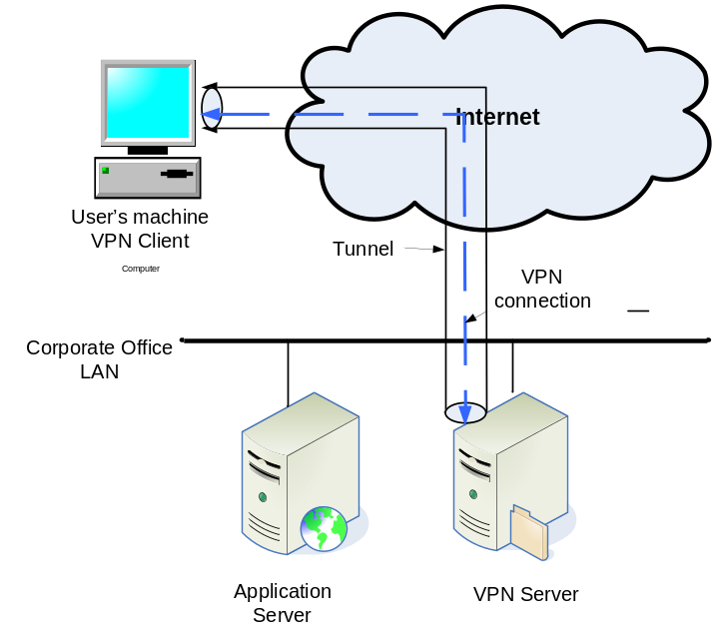
Figure 3-2 Remote access VPN model
Figure 3-2 illustrates a remote-access VPN model to support a remote user to access an application server (e.g. web server) on the corporate office LAN.
The remote user is connected to the Internet through either dial-up or Ethernet connection. The VPN client on the user’s computer establishes a secure VPN connection to the VPN server maintained at the corporate network. The request from the user is encrypted and then sent to the VPN server through the VPN connection. The data is encrypted until it reaches the VPN server. The VPN server then decrypts the received data and forwards it on to the target application server. Thus the remote user can communicate with the application server just as securely over the public network as if it resided on the internal corporate LAN.
From the user’s perspective, the VPN connection is a point-to-point connection between the user’s computer and the company’s application server. However, the information that the user sends out will lose its VPN level of protection when the VPN server receives it and sends it along to the application server. After that point, security is the user's and the application server's responsibility. For example, you should not send password or credit card information to a Web page that is not SSL-encrypted (e.g., a page does not begin with https://), even if you're using a VPN connection.
Therefore, a VPN client does not replace antivirus software, operating system and any local-area networking security practices. A virus that is downloaded in an encrypted packet will still infect your system when your VPN client decrypts it for your applications to read.
The Site-to-Site VPN Model
A site-to-site VPN refers to a wide area network (WAN) implementation in which the network of one location is connected to the network of another location via a VPN. It is often used to connect branch offices, home offices, or business partners' sites to all or portions of a company's network. Rather than a client-server connection, it can be viewed as a server-server VPN connection that joins two networks to form an extended intranet or extranet.
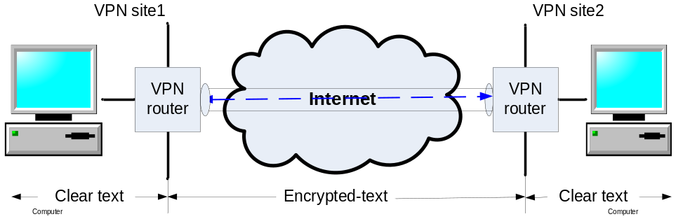
Figure 3-3 Site-to-site VPN model
In a site-to-site VPN, there are VPN servers at each site to authenticate each other and establish the VPN connection between the sites. VPN servers can act as gateways (internetworking devices) to the computers behind it on the subnet, securely passing traffic through end-to-end encrypted tunnels between the sites. This is also referred as gateway-to-gateway VPN application. VPN routers with firewall function can support this functionality and also provide network-level protection of remote-site resources and filtering of traffic.

Figure 3-3 shows a site-to-site VPN model, in which the remote sites use the VPN router to provide both firewall function and VPN connectivity between two sites. When information is transmitted from one location to anther, the VPN router at one location encrypts information before sending it through the VPN connection on the Internet. At the other location, the receiving VPN router decrypts the information into clear-text and sends it to its LAN.
Cisco IP VPN Solutions
Cisco has VPN products to support both remote-access VPN and site-to-site VPN. For remote access VPNs, there are Cisco VPN 3000 Series Concentrators, the PIX Firewall and the Cisco VPN client. For site-to-site VPNs, there are Cisco VPN routers and the PIX Firewall.
Cisco Remote Access VPNs
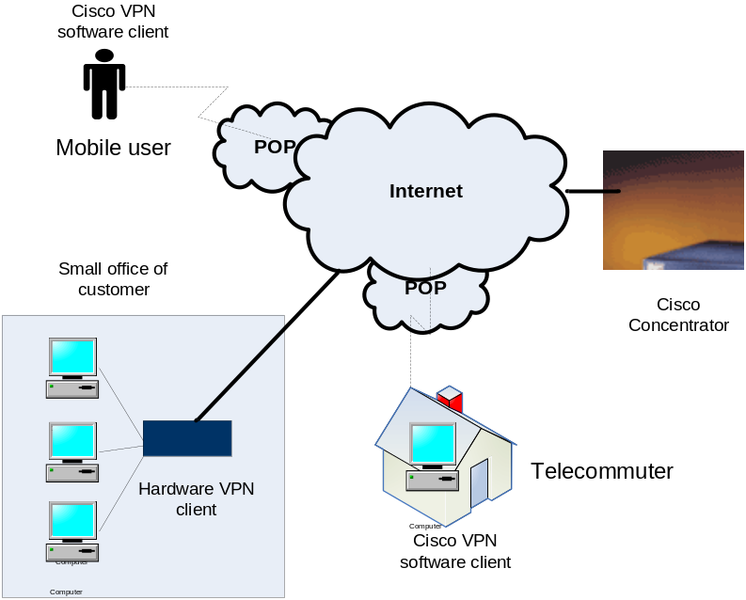
Figure 3-4 Remote access VPNs – Cisco VPN client and Concentrator
In a remote-access VPN model as shown in figure 3-4, the mobile user and telecommuter have Cisco VPN software client loaded on their PCs. The customer has a standalone Cisco hardware client located in its small office. On the corporate end, a Cisco Concentrator is placed to function as a VPN server. The Concentrator can communicate with both Cisco VPN software client and Cisco Hardware client. Note that a small Cisco Pix Firewall can act as a VPN server as well.
VPN connections are formed from the VPN client to the VPN server (i.e. Cisco Concentrator). The Cisco VPN client allows secure connection between client machines and the VPN server. The VPN server terminates VPN connections initiated by remote users running Cisco VPN software client on their PCs. This flexibility makes it possible for remote or mobile users, such as sales people on the road or telecommuters, to access their headquarters intranet where critical data and applications exist. The VPN server can also terminate VPN tunnels initiated from customer’s VPN hardware client to enable customers with limited access to the company’s corporate resource.
VPN Concentrator series is built specifically for creating a remote-access VPN with the most advanced encryption and authentication techniques available. It authenticates individual remote users and terminates their VPN connections. It includes components that enable users to easily increase capacity and throughput. The concentrator series is offered in models suitable for everything from small businesses with up to 100 remote-access users to large organizations with up to 10,000 simultaneous remote users.
Cisco Site-to-Site VPNs
Cisco provides a suite of VPN-optimized routers and PIX Firewall 500 series to cover the entire spectrum of VPN site-to-site applications.
Cisco VPN-optimized routers from the 800 series to the 7200 series routers can be scaled to meet different VPN requirements and network sizes, from small-office/home-office access through central-site VPN aggregation, to large-scale enterprise needs.
VPN-optimized routers provide VPN solutions for hybrid VPN environment where modularity, port density, and flexibility are required for private WAN aggregation and other classic WAN applications. As shown in figure 3-5, these routers run the range of VPN applications from small offices/home offices with the Cisco 800/900 series; to small branch office connectivity with Cisco 1700/2000 series; to enterprise partner branch with Cisco 3600/3700 series; and to enterprise headquarters high-end VPN connectivity with Cisco 7100, 7200, 7400 series routers.
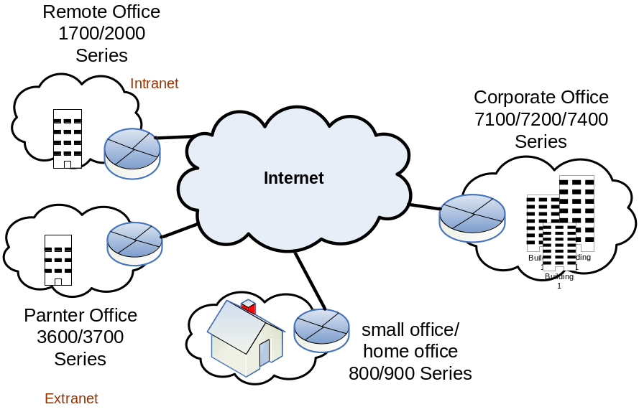
Figure 3-5 Site-to-Site VPNs – Cisco Routers
Cisco secure PIX (private Internet exchange) firewall can be used in remote site. It combines dynamic network address translation, proxy server, packet filtration, firewalling and VPN capabilities in a single piece of hardware. The primary role of the PIX firewall is security while the secondary role is terminating VPN traffic. It has the ability to handle a variety of protocols for extreme robustness and performance. The 500 series PIX firewall product is best positioned to satisfy the security requirements.

Lesson Wrap-Up

There is a growing demand for VPNs. Cisco's unique end-to-end VPN products support both remote-access VPN and site-to-site VPN and allow customers to secure their network infrastructures without costly changes to every computer. With VPN deployed in your network, applications gain privacy, integrity, and authenticity controls without affecting individual users or applications.
Now that you have completed this lesson, you should be able to:
- Discuss the basic components of a VPN
- Describe how remote-access VPN and site-to-site VPN work
- Introduce Cisco’s VPN solutions

Lesson 4 Fundamental IP security (IPSec)

Lesson Objective

The main concern of using any type of VPN is security while crossing the public Internet. Most VPNs rely on the Internet Protocol Security (IPSec) to manage security issues, such as loss of privacy, identity spoofing, and denial-of-service. The goal of IPSec is to address these threats in the network infrastructure itself without requiring expensive host and application modifications. This lesson presents an overview of IPSec along with its four critical security services.

After reading this lesson, you should be able to:

- Define IPSec and explain basic concepts of IPSec
- Explain four critical IPSec security services

What is IPSec?

Short for Internet Protocol Security, IPSec is a framework of open standards to provide security for transmission of sensitive information over unprotected networks such as the Internet. IPsec has been deployed widely to implement Virtual Private Networks (VPNs).
The IPSec protocol typically works on the edges of a protected network domain. It supports secure data exchange between a pair of participating IPSec devices (peers), such as PIX Firewalls, Cisco routers, Concentrators, Cisco VPN Clients, and other IPSec-compliant products. For example, IPSec can encrypt data between a Cisco router to another Cisco router, a firewall to a router, a PC to a router or a PC to a VPN server (e.g. Concentrator).
Basically, IPSec provides security by building tunnels between two peers. You define which packets are considered sensitive and should be sent through these secure tunnels. When the IPSec peer sees such a sensitive packet, it encapsulates a packet by wrapping another packet around it. This wrapped traffic forms a secure tunnel through which the packet is sent to the remote peer across an otherwise unsecured network.
IPsec has two main framework protocols: Authentication Header (AH), which essentially allows authentication of the sender of data, and Encapsulating Security Payload (ESP), which supports both authentication of the sender and encryption of data. ESP and AH can either be used together or separately, depending on the environment

IPSec is not bound to any specific encryption or authentication algorithms, keying technology, or security algorithms. It allows for newer and better algorithms to be implemented without patching the existing IPSec standards.

IPSec Security Services

IPSec provides four critical security services.

Confidentiality (encryption)

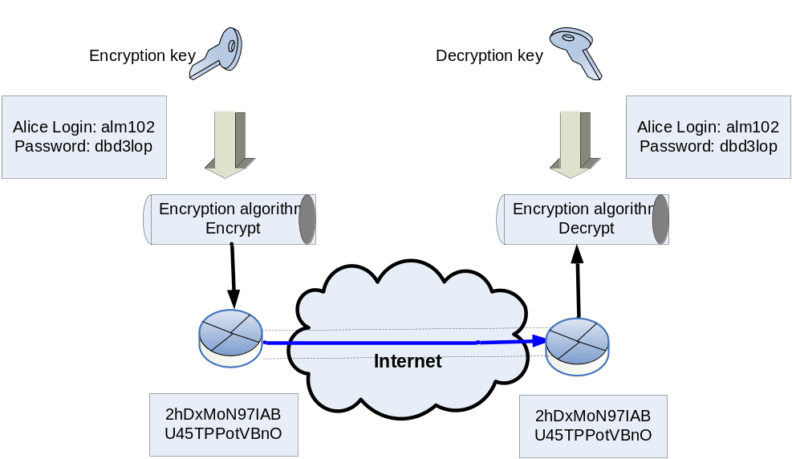

Figure 3-6 Confidentiality (Encryption)

Confidentiality protects the privacy of information being exchanged between communicating peers. Clear text data transported over the public Internet can be intercepted and read. In order to keep the data private, the sender can encrypt the packets before transmitting them across a network.

Encryption is a technique that scrambles information (so that it is difficult or impossible to read) and unscrambles information (so that it can be read again). For encryption to work, both the sender and receiver need to know the rules used to transform the original message into an unreadable cipher-text. Rules are based on an encryption algorithm and a key.

An encryption algorithm is a repeatable technique for scrambling (encrypting) and unscrambling (decrypting) information that can be performed by people or computers.
A key is a secret code that is used by the encryption algorithm to create a unique version of the cipher-text. There are two types of encryption keys: symmetric and asymmetric. With symmetric key encryption, each peer uses the same key to encrypt and decrypt the data. With asymmetric key encryption, the local end uses one key to encrypt, and the remote end uses another key to decrypt the traffic.

For example as shown in figure 3-6, a file containing login and password information for a user Alice needs to be sent across the Internet. At the local end, the document is encrypted by an encryption algorithm combined with a key. The output is unreadable cipher-text. The cipher-text is then sent through the Internet. At the remote end, the message is recombined with a key and sent back through the encryption algorithm. The output is the original document in clear-text.

Data integrity

Integrity ensures that the data is not changed or tampered in any way during transmission over the public Internet. There are the following three technologies to guarantee integrity of the data:

One-way hash functions – A hash function is a one-way algorithm that transforms an arbitrarily large message into a unique fixed-length number (called hash or hash value). Hashing is not an encryption and this process is irreversible, meaning it is computationally impossible to derive the original message from the hash.

For example, for a message 'LOGIN'
L = [0, 1, 0, 0, 1, 1, 0, 0]
O = [0, 1, 0, 0, 1, 1, 1, 1]
G = [0, 1, 0, 0, 0, 1, 1, 1]
I = [0, 1, 0, 0, 1, 0, 0, 1]
N = [0, 1, 0, 0, 1, 1, 1, 0]
A hash value can be generated by XOR-ing each byte of the message, that is L XOR O XOR G XOR I XOR N.
With XOR operation,
0 XOR 0 = 0
0 XOR 1 = 1
1 XOR 0 = 1
1 XOR 1 = 0
Therefore, the hash is 01000011. You cannot derive the original message 'LOGIN' from the hash 01000011.
The method of one-way hash functions validates the integrity of the original message by attaching a hash to each message. The hash is transmitted from the local end to the remote end with the original message. At the remote end, if the hash calculated from the received message using the same hash function matches the hash it receives, the message has not been altered; otherwise, the message was altered. Examples of hash algorithms are MD5, SHA-1 and RIPE-MD-160.

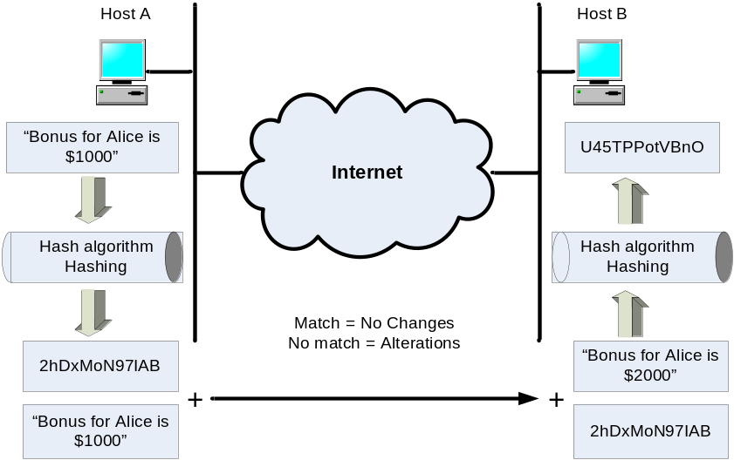

Figure 3-7 Data integrity – Hash function

Example – Let’s look at an example in which the manager on host A sends a HR person on host B a message “Bonus for Alice is $1000”, as shown in figure 3-7. The manager does not care if the message would be seen by others, but he wants to make sure that any changes to the message during transit will be signaled at the remote end.

In this example, we don’t need consider data confidentiality; however we do need to consider data integrity which can be accomplished using the following steps:

1. Host A generates a hash for the original clear-text message using a hash function
2. Host A sends both the clear-text message and the generated hash to Host B
3. Host B receives the message and the hash from host A
4. Host B generates a hash from the received message. The newly generated hash ‘U45TPPotVBnO’ does not match the received hash ‘2hDxMoN971AB’; therefore, the received message has been altered during transmission

Note that the method used in this example is not very secure because the attacker may alter the original hash if he/she knows the hash function used by the sender. For example, the attacker can change the message to ‘Bonus for Alice is $2000’, and then calculates a new hash based on the changed message using the same hash function used on host A. Host B cannot tell if the message has been altered when receiving the forged message and hash. A hash function combined with a key is more secure because the attacker has no knowledge about the key.

Hashed message authentication codes (HMAC) – HMAC adds a key to hash functions. A sender would create a message, and calculate a hash value by sending the message and a shared secret key through a hash algorithm. The message and hash value are sent over the network. When the recipient receives them, it re-calculates the hash value by sending the received message and shared secret key through the same hash algorithm. If the original hash and re-calculated hash match, the integrity of the message is guaranteed. If any part of the original message is changed during transit, the hash values are different.
Digital signatures – Digital signature guarantees that the information received is authentic and has integrity, that is to say, the information is from the system which claims to have sent it and the information has not been altered in any way. To guarantee the integrity of a message, you create a digital signature for that message and include it with the message, which is referred to as a signed message. This will be discussed more in topic 6.
Origin Authentication

Origin authentication ensures the identity of the source of participating IPSec devices, guaranteeing and certifying the source of the packets. VPN typically uses one or more forms of authentication which are usually based on the following methods:
Password authentication (shared secrets) – is the most prevalent form of user authentication used in computer system today. Strong password such as One-time-password (OTP) and encrypted password are recommended as a stronger form of authentication. For example, many VPNs support SecurID, a token card that combines secret key encryption with a one-time password. The password is automatically generated by encrypting a timestamp with the secret key. This one-time password will be valid for a short interval, usually 30 to 60 seconds.
Digital Certificate – is a technology to let people and systems authenticate or identify each other without using passwords. Digital certificate relies on digital signature technology. A digital certificate is a special type of signed message that ties to a sender. The sender digitally "signs" a document with their private encryption key and the recipient can verify the signature via the sender's public key. If the signature is genuine, the sender is authenticated. It is used during the initial establishment of a VPN tunnel to authenticate both ends to the tunnel. There are two common digital signature algorithms: RSA and Directory System Agent (DSA).
In VPN networking, it is necessary to authenticate the device on the other end of the VPN tunnel before the communication path is considered secure. This is called peer authentication. There are three peer authentication methods.

Pre-shared keys – Manually enter a secret key value into each peer to authenticate the peer.

RSA signatures – Uses the exchange of digital certificates to authenticate the peers

RSA encrypted nonces – Uses the RSA encryption public key cryptography standard. Each peer generates a random number (nonce) and encrypts it in the other party’s RSA public key. The nonces are then exchanged between peers. The two nonces are used during the peer authentication process.

Anti-replay protection

Anti-replay protection verifies that each packet is unique, not duplicated. IPSec packets are protected by comparing the sequence number of the received packets and a sliding window on the destination host. The sequence number indicates the number of packets sent over the security tunnel for the communication. The destination host checks the sequence number against the sliding window to verify if a packet is considered late or duplicate. Late and duplicate packets are dropped.

Lesson Wrap-UP

IPSec provides numerous security features that enable encrypted communication between users and devices. It is ideally positioned to enforce corporate network security and can be implemented transparently and seamlessly into the network infrastructure. IPSec security headers are inserted between the standard IP header and the upper-layer data (e.g. a TCP packet), and therefore any network service or user applications that use IP (e.g. Telnet and FTP) can use IPSec without modifications. Also, IPSec traffic can pass transparently through existing IP routers on the Internet.

Now that you have completed this lesson, you should be able to:

- Define IPSec and explain basic concepts of IPSec
- Explain four critical IPSec security services

Lesson 5 IPSec Security Protocols

Lesson Objective

IPSec is a framework of open standards for ensuring secure private communications over the Internet. IPSec provides security services to ensure confidentiality, integrity, and authenticity of data communications across the Internet. The security services within IPSec are provided by one of two protocols, the Authentication Header (AH) and the Encapsulating Security Payload (ESP). Each protocol provides certain services and may be used separately or together.

This lesson will explain how each of these two protocols provides security service and how IPSec works in steps.

After reading this lesson, you should be able to:

- Describe Authentication Header (AH)
- Describe Encapsulating Security Payloadv(ESP)
- Discuss modes of use of IPSec
- Define IKE and list operation steps of IPSec
.

Authentication Header (AH)
Authentication Header (AH) provides origin authentication and integrity for IP packets passed between two systems. Integrity means the original IP packet was not modified in transit from the source to the destination. Origin authentication means the data was truly originated from the two communicating systems and the data was not generated by impersonator.
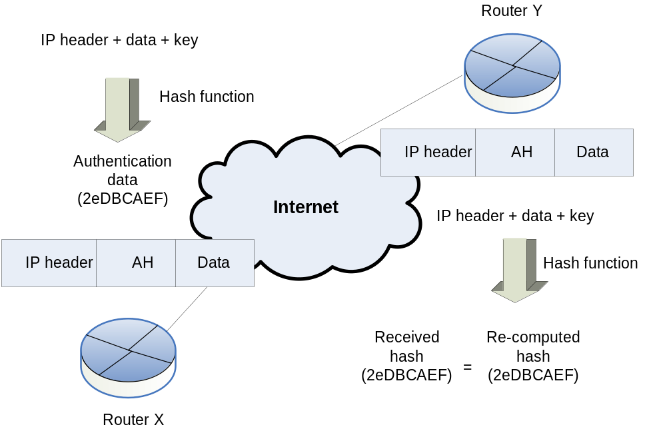
Figure 3-8 AH Authentication and Integrity
The origin authentication and integrity functions are achieved by applying a keyed one-way hash function to the packet to create a hash (AH). The AH is combined with the original message and transmitted. Changes in any part of the packet that occur during transit are detected by the recipient when it performs the same one-way hash function on the received packet, and compares the value of the hash that the sender has supplied. By re-computing AH using the received message, and comparing it with the hash value received, the receiver can verify if the message has been altered or not during transit.

As shown in figure 3-8, AH works as follows:

1. The IP header and data payload is hashed through a hash function to create AH
2. The AH is inserted into the IP packet between the IP header and the data (payload)
3. The new packet is transmitted from the IPSec peer router X to router Y
4. The peer router Y receives the packet and hashes the IP header and data payload
5. The peer router Y compares the AH from the received packet with the AH it re-computed in step 4. The two AH must exactly match. Even if one bit is changed in the transmitted packet, the hash output on the received packet will change and the AH header will not match.

There are different algorithms that can be applied to calculate AH such as hashed-based message authentication code (HMAC) coupled with the Message Digest 5 (MD5) hash function and HMAC coupled with the SHA-1 hash function.

AH also provides an anti-replay service that can be used to counter a denial-of-service attack. Note that AH does not keep the contents of the packets confidential (data encryption), and all text is transported in the clear. Therefore it is not widely used for IPSec implementations across the Internet. For confidentiality, the ESP must be used.
Encapsulating Security Payload (ESP)
Encapsulating Security Payload (ESP) provides confidentiality (encryption), origin authentication and integrity, which protect against data tampering and, importantly, provide data content protection.
ESP provides confidentiality by performing encryption for the IP packet. IP packet encryption conceals the data payload and the identities of the ultimate source and destination. ESP supports a variety of symmetric encryption algorithms to encrypt the packet payload. The default algorithm for IPSec is 56-bit DES. Cisco products also support the use of 3DES for stronger encryption.
The ESP encryption by itself does not provide authentication or data integrity, so you should use ESP encryption with an authentication and data integrity service. There are two ways to do this: use the authenticated ESP format, or combine ESP within AH (nested ESP in AH).

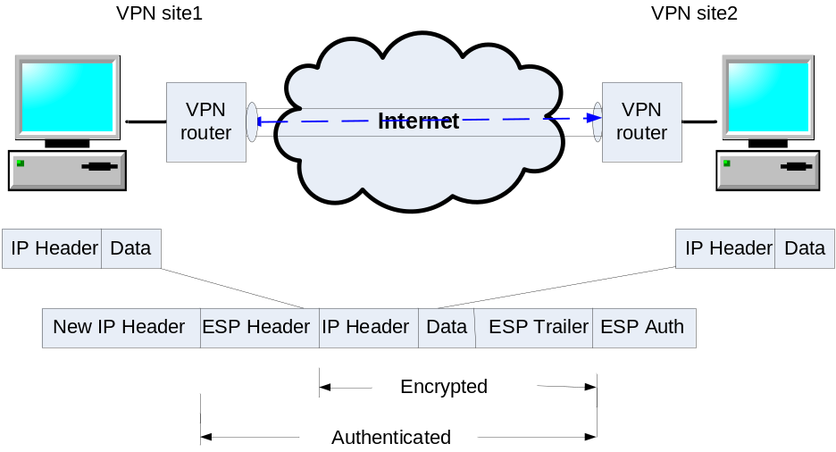
Figure 3-9 Authenticated ESP
With authenticated ESP, IPSec first encrypts the payload using one symmetric key, and then sends the encrypted payload with a second symmetric key through a hash algorithm, such as HMAC-SHA1 or HMAC-MD5, to calculate an ESP authentication value. The authentication value is used to provide origin authentication and data integrity for the data payload. It is appended to the end of the packet as shown in figure 3-9. The recipient computes its own authentication value for the encrypted data payload using the second symmetric key and the same algorithm. The recipient compares the result with the transmitted authentication value. If the values match, the recipient then decrypts the encrypted portion of the packet with the first symmetric key and extracts the original data.
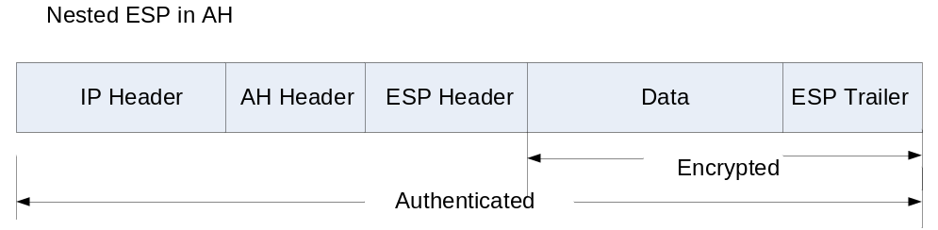
Figure 3-10 Nested ESP in AH
The second method allows an ESP packet to be nested within an AH packet as shown in figure 3-10. For example, a 3DES ESP packet can be nested within an HMAC-MD5 packet. IPSec first uses 3DES to build an ESP packet with the data payload encrypted using a symmetric key. IPSec then nests the ESP packet within an AH packet, using a second symmetric key. All the contents of the packet are authenticated, except the mutable fields of the IP header.
Alternatively, ESP may also enforce anti-replay protection by requiring that a receiving host set the reply bit in the header to indicate that the packet has been seen.

For the example as shown in figure 3-9, between two IPSec peer routers, the original payload is well protected because the entire original IP data packet is encrypted. An ESP header and trailer are added to the encrypted payload. With authenticated ESP format, the encrypted IP data packet and the ESP header or trailer are included in the hashing process. Last, a new IP header is placed to the front of the authenticated payload. The new IP address is used to route the packet through the Internet.

When both ESP authentication and encryption are selected, encryption is performed first before authentication. Prior to decrypting the packet, the receiver can authenticate inbound packets. This order of processing facilitates rapid detection and rejection of replayed or bogus packets by the receiving IPSec device. By doing this, it can detect the problems and potentially reduce the impact of denial of service (DoS) attacks.
Internet Key Exchange (IKE)
As noted above, AH and ESP need to share secret key between IPSec peers. Internet Key Exchange (IKE) provides ways to negotiate keys in secrecy for communication between distant locations. It is designed to securely establish a trust relationship between each IPSec peer, to negotiate security options, and dynamically generate shared secret key. The agreement of security settings associated with keying material is called a security association, also known as an SA. These keys will provide authenticity, integrity, and optionally, encryption of IP packets that are sent using the security association.
IKE is optional. You can configure secret keys manually for AH/ESP. However, traffic can be easily compromised when repetitively using the same secret key for a long period of time. If secret keys are compromised, IPsec protocols can no longer be secure.
Modes of Use
IPsec can either be used to directly encrypt the traffic between two peer devices (known as Transport Mode); or to build ``virtual tunnels'' between two subnets, which could be used for secure communication between two corporate networks (known as Tunnel Mode). The latter is more commonly known as a Virtual Private Network (VPN). Figure 3-11 shows the transformed IP packets in these two modes of use.
The transport mode only encrypts the IP payload, but leave the IP header untouched (in the clear). It allows devices on the public network to see the source and destination IP address in the IP header in order to route the packet through the Internet. Unfortunately, by passing the IP header in the clear, transport mode allows an attacker to perform some traffic analysis. For example, an attacker could see when a company sent a lot of packets to another company. However, the attacker would only know that IP packets were sent; the attacker would not be able to determine the content of the data, for example, if they were e-mail or another application.
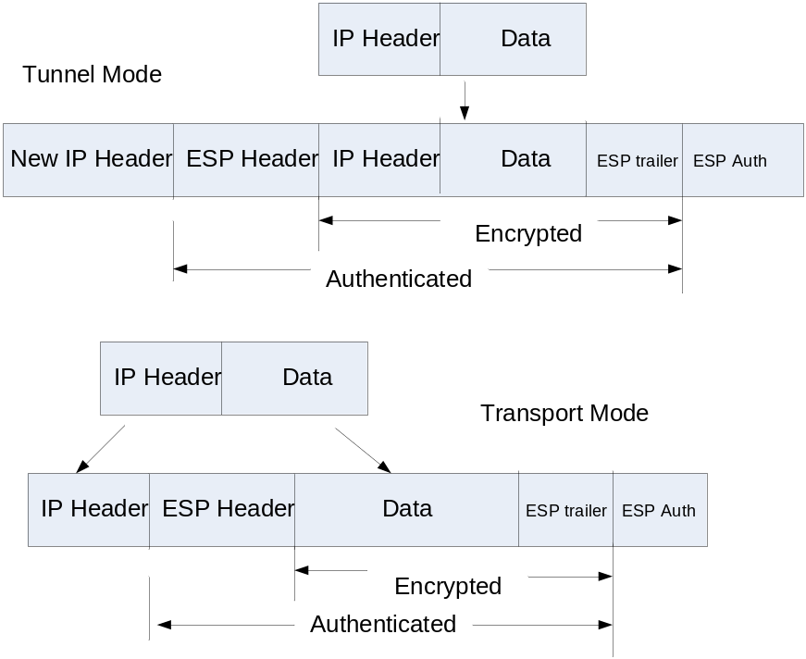
Figure 3-11 Modes of Use – Tunnel Mode and Transport Mode
IPSec transport mode can only be used when both the source and the destination systems understand IPSec.
The tunnel mode encrypts the entire original IP datagram, and the result becomes the payload in a new IP packet. This mode is used when either end of the tunnel is a security gateway, such as a Concentrator, a VPN optimized router, or a PIX Firewall. The security gateway performs encryption and authentication of the original IP packet on behalf of the hosts. Next, a new IP header is appended to the front of the encrypted packet. The new IP address is used to route the packet through the Internet to the remote end security gateway. Then the destination gateway decrypts the original IP datagram and forwards it on to the destination host based on the original IP header.

Tunnel mode provides security for the whole original IP packet. It encrypts both the header and the payload of each packet. On the receiving side, an IPSec-compliant device decrypts each packet.

The big advantage of tunnel mode is that the end hosts do not need to be modified to enjoy the benefits of IP Security. For site-to-site applications, the security gateway can simply perform the encryption and encapsulation rather than loading IPSec on all the computers at the remote and corporate offices. For remote-access applications, the IPSec client running on the PC at a home office performs the IPSec encapsulation and encryption and at the corporate office, the router de-encapsulates and decrypts the packet.

Tunnel mode also protects against traffic analysis. With tunnel mode, an attacker can only determine the tunnel endpoints and not the true source and destination of the tunneled packets, even if they are the same as the tunnel endpoints.

How IPSec operates

The goal of IPSec is to protect the desired data with the needed security services. Figure 3-12 illustrates how IPSec operates between two IPSec peer routers in five primary steps:

Step1. Interesting traffic – The IPSec peer routers X and Y recognize the traffic you want to protect.

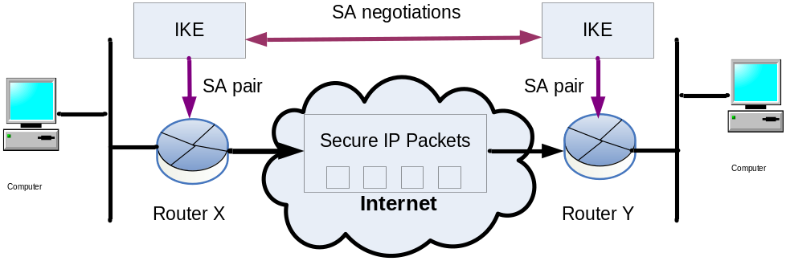

Figure 3-12 IPSec operation steps

Step2. IKE Phase I – The IPSec peer routers X and Y negotiate IKE policy sets used to protect all subsequent communications, authenticate each other and set up a secure communications channel between them.

Step3. IKE Phase II – The IPSec peer routers X and Y negotiate IPSec SA parameters, and set up matching IPSec SAs in the peers to protect data and message exchanged between them.

Step4. Data Transfer – The IPSec peer routers X and Y transfer secure IP packets based on IPSec SA parameters and defined security services.

Step5. IPSec tunnel termination – IPSec tunnel is terminated through deletion or by timing out.

Lesson Wrap-Up
IPSec provides the power to enable privacy, integrity, and authenticity for customers’ network infrastructure. These security services are provided by two important protocols AH and ESP. AH provides data authentication to IP packets, helps to reduce IP spoofing and provide the possibility of non-repudiation. ESP provides data confidentiality and data authentication to the payload of IP packets.
AH and ESP can operate in two modes of operation—transport and tunnel mode. In most cases, you deploy IPSec with tunnel mode. Doing so allows you to implement IPSec in the network architecture without modifying the operating system or any applications on your PCs, servers, and hosts.
Now that you have completed this lesson, you should be able to:

- Describe Authentication Header (AH)
- Describe Encapsulating Security Payloadv(ESP)
- Discuss modes of use of IPSec
- Define IKE and list operation steps of IPSec

Lesson 6 Topic Wrap-Up

The Internet holds unlimited promise for changing the way we do business, but not without first addressing the security risks. Recently, many companies have turned to virtual private network (VPN) technology to supply secure network connectivity across a shared infrastructure (i.e. the Internet) and cost-effectively extend their corporate networks to locations that may not have been justified before.
There are an ever-increasing number of types of VPN available. Many of them use Internet Protocol Security (IPSec) to enforce data privacy, integrity, authenticity, and anti-replay protection for network traffic. IPSec provides a key piece of the solution and will work in concert with other security mechanisms and help your organization become a global networked business.
The security services of IPSec are provided through the combination of specific encryption or authentication algorithms, keying technology, or security algorithms. We will discuss these technologies in the next few topics.
Now that you have completed this topic, you should be able to:

- Give an overview of VPN including its benefit, different types and its security mechanisms.
- Describe the implementation of two different types of VPN
- Introduce IPSec and the security services provided by IPSec
- Discuss two important protocols supported by IPSec: AH and ESP

